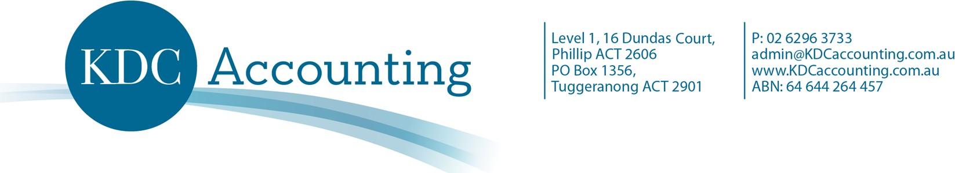

Experienced Bookkeeper – in Accounting Firms

Who are we?
We are a locally based firm that has been operating in Canberra for 19 years. We specialise in individuals and small business. Whilst much of what we do is compliance based, we are work closely with our clients in achieving their financial and personal goals.

Why is this position vacant?
Due to recent growth and awesome client referrals, we need an experienced Bookkeeper keen to work on compliance, and help our clients.

What we can offer you:
- Small and friendly team environment where everyone's input is valued,
- PD opportunities,
- Honest, open, and appreciative clients who are a pleasure to deal with,
- Free parking, we are conveniently located in Phillip

Who do we want?

We are looking for a bookkeeper with experience with several record keeping programs such as Xero, MYOB, and QBO. Experience in only one will not be a disadvantage, provided you are prepared to proactively learn the others.
We want someone who will work with our clients from our office. There is definitely opportunity for working from home.
We are looking for someone for a permanent roll with our firm - preferably full-time but we will consider part time for the right candidate.
As a permanent team member, you will be entitled to annual leave, sick leave, and public holidays.

How will you fit into our team?
At KDC Accounting, we are a dynamic, proactive, and growing accounting business and our clients think so too. We currently have a team of 7 accounting professionals looking after more than 1000 clients who are predominantly small business clients and individuals.
We offer our clients quality and peace of mind around their compliance requirements, and help them to understand their financial matters more fully.
We also facilitate the growth and success of our clients running their own businesses. Our Clients appreciate what we do and tell us, and refer their friends and colleagues to us. They value our advice and support, which is timely and practical.
We value our strong relationships with our clients and know you will too!

Do you enjoy providing value, advice, and support to your clients?

Do you appreciate that your work and advice needs to be timely and practical? Do you value strong relationships with your clients?
If this sounds like you, please get in touch.

Other Details:
- We use the Handisoft suite of products incl Practice Manager, Jobflow, Document Manager, Best Practice, HandiTax, and HandiLedger. It's simple and easy to learn, whilst providing fantastic features. If you haven't used it before, you will soon fall in love with it.

- We also use Xero, MYOB, and QBO

- We are self-confessed PD Junkies,

- We are systematised in our processes to make your job easier and efficient,

- We are involved in our profession and community and would support you if this is your desire, and if it's not, that's ok too.

- We have modern, fully functioning technology and have dual screens on all desks.
- We are looking for someone to work closely with our clients.

Your duties may / will include:

- Preparation of Business Activity Statements Data entry from source documents for a couple of small businesses using a variety of programs, most specifically MYOB, Xero, and QBO.

- Providing Support to the accountants in relation to the various programs our clients use as we prepare their year-end work

- Assisting with the training of our clients to use various record keeping programs/Apps, both formally and informally.

- Keeping our firm at the forefront of the technology advances, proactively implementing and integrating technology improvements for our clients,

- Payroll tax, super reconciliations, and similar as required for our clients.

- BAS preparation for our clients

This position is predominantly helping clients with their own data entry. It requires someone confident in explaining the process with clients, reconciling their data files after the client has processed the entries, and investigating the data file to improve the quality of the clients' data.

Are you interested?
Please apply by sending an email to admin@kdcaccounting.com.au and be sure to include an application / covering letter along with your CV / resume.

Applications without a covering letter will not be considered.

